**UOM email chain** The sample data shared had 5 UPC’s . Two of them were sold ‘Loose’ and remaining as ‘Pre-packaged’. Transaction data attributes such as ‘‘GTIN Unit of Measure Amount’,’ Retail Dollar Amount’, ‘Weight Flag’,   can help us in inferring the UOM.

Below is a snap shot from a sample analysis.   To continue our study, please share similar data for items of category ‘Build to sell’ and ‘Transformed to Sell’.  Also the store inventory data for the item will be helpful.   I will ask – in the meantime, we should continue to work on these items

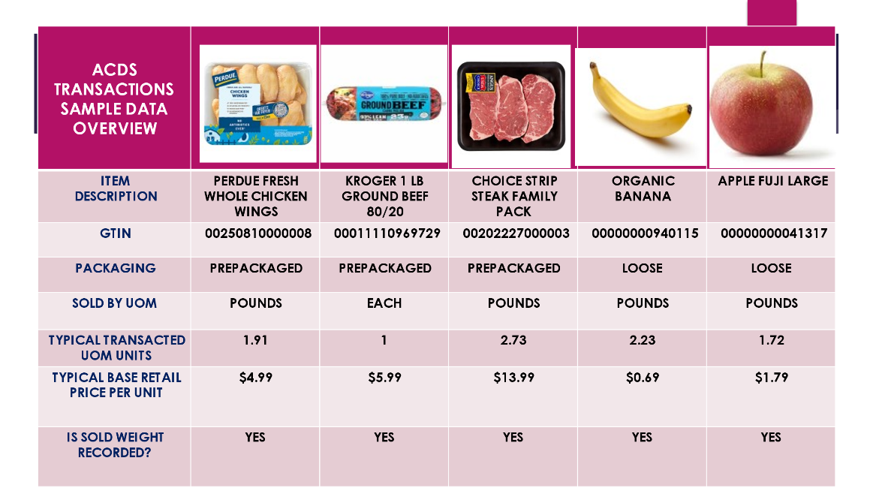

The Open questions that we had : Few of these were already answered.

* Are stores graded based on managing produce inventory.?  Stores graded on Days of Supply (DoS) in produce, based on inventory quantity and $ value on hand.  There are some produce commodity targets, but I am not sure there are targets on all produce items yet.  Stores are also evaluated on shrink (reducing shrink) and markdown compliance, which are affected or related to inventory.
* How many items have multiple UOM by sales channels. E.g. online by each, in store by lb. or some time by oz?  For produce, loose produce commodities would all have the potential for being sold in eaches or weight, usually pounds.  Nothing by ounce, to my knowledge, in produce, meat or other key fresh categories.
* How is the supplier variability between case/weight/each analyzed. ?  Right now, that variability is obscured due to “dummy item” setups.  In the future, with RMS, the supply chain will not have dummy items, so every variation (different case size, weight, quantity) will have its own GTIN (case bar code/reference).  This would mean we could track variability by item more easily.  For variations within a single item, we would need to establish a process for how and when to review changes to weight, for example.
* Can balance inventory be predicted with an acceptable degree of error based on history of store sales , seasonality etc. ?
* Can supplier provide count along with weight ? For packaged items, yes – they should already include the count.  For loose produce, it will be difficult.  As an example, a 40 lb. box of bananas is ordered by case.  That case weighs 40 lbs, but could vary within a specified range.  The actual number of bananas inside that will vary, since banana size may vary and number of bananas per bunch can vary.  For loose produce, it would be easier to work toward an aggregated weight/each number by working with suppliers.  (Meaning, supplier provides the weight of an average banana or fuji apple, and could update that seasonally, quarterly, annually, etc.; if we have an average weight per each number and a case weight, then we can do the math to determine how many eaches are in a case)
* As item data move from master ( PID/PIM ) to warehouse / store and sales systems how and why does the UOM varies? UOM varies in stores based on promotional needs (store selling an item 3 for $1 on promotion, but usually by weight) or for online fulfillment in store (online by each, in store register transaction by weight).  Warehouse always buys from suppliers by the case and ships in cases to the store (warehouse orderable UOM = case).

My personal opinion is solving for the UOM within the store (transactions, accounting, inventory/BOH) should, in theory, mean that our store orders become more accurate – which in turn drives more accuracy at the warehouse level.  That should reduce the amount of store adjustments being done (something stores also get graded on) and result in more consistent supply of fresh items relative to demand.

Understood from the meeting that the stores are graded based on how they manage inventory. Can we get access to that report or list of few leading stores so that we can analyze inventory management in them and compare with laggers.  I’ll see what I can get on this

Sample data needed for next step **RE: Meeting minutes **RE: Challenges with missing UOM in POS transactions for meat business

08.25.23 - Deevraj

* Produce business function has data residing in various types and forms in multiple legacy systems. Getting an end-to-end visibility of the process and underlying data in a connected ecosystem can help in brining huge uplift for automating many of the business functions and enabling buyers to focus on problems rather than manual ordering
* Challenges faced by various teams with UOM issues includes
  + RDF – Blended forecast depends on the data feed from ‘Hearbeat’ which depends on Sales transactions. As UOM is missing, RDF team struggles on forecasting. It impacts the downstream functions such as warehouse ordering
  + RMS – Though there is capability to store two UOM, lack of visibility to actual sales quantity will lead to wrong UOM being selected in PO. This  leads to surplus/ shortage in item inventory
  + E-commerce – Items are sold in packs / each. Capturing the corresponding weight of the item decremented is critical for item replenishment.
  + POS – In store inventory decremented can impact POH as well as store orders which in turn feeds to warehouse orders
* Objectives of Q3 are
  + Item cleanup
  + Fresh promotional process mapping

Action Items:

* Use AI approach to predict UOM of the POS transactions. Execute a POC for a selected category
* Provide sample data from the category selected for estimation of effort

Please add/modify the points that I might have captured partly.

08.25.23 - Deevraj to Graig

As we discussed yesterday, we can approach this problem by taking one small category for a POC. I hope meat is relatively small and we can address it in a quarter.

Please share with me sample data from

* POS transactions
* Promotions executed for the selected category for the period
* Store and warehouse inventory for the item for the period
* RMS order data ( if possible ) for the item

Also let me know the transaction volume so that we can estimate the effort required to update the UOM.

**08.25.23 – Graig to Deevraj**

Caroline – can you work with Lisa to see if there’s a good meat SKU (item) that has good RMS order data?  Probably keep this small, maybe give us 2-3 choices.

Deevraj – Once Caroline gets me that, I’ll work with the teams required to get data on the POS, promotions, and inventories.

Did we want to look at 1 quarter’s data?  What were you thinking in terms of the length of the period involved?

**08.25.23 - Deevraj to Graig**

Thanks Craig! . For estimation we only need sample data (  representative transactions )  from each system ( data should be related  so that we will be able to connect the inventory data for a POS transaction).

AI algorithm’s has to be trained with historic data for predictions. The more the training dataset, the better the prediction accuracy  will be.  If possible, we train the algorithm with 2 years of historic data. But if it’s not available, we have certain work arounds. Please share whatever is possible.   The team need not share all the data in one shot. They can take couple of weeks to deliver the complete dataset.

**08.28.23 – Graig to Deevraj**

Thanks Deevraj!  I’ll see how much data we can get to you once we identify the items.

Caroline – quick question – are there any random weight produce items that might work to test here too?  I realize they would have to be EDI not iTrade, but thought I’d ask.

If we could find even 1 item in produce that might also give us a better idea of any differences between the categories, etc.

**08-30-23-** Caroline

Apologies for my delay in getting this to you. I pulled what is listed in RMS, but unsure how correct these attributes are. Here are a few item options:

|  |  |  |  |  |  |  |  |  |  |
| --- | --- | --- | --- | --- | --- | --- | --- | --- | --- |
| SKU | Case | Consumer SKU | Consumer | Description | Standard  UOM | RMS Selling UOM | RMS Packaging UOM | Location | Notes |
| 100100717 | 0020222700000 | 100100717 | 0020222700000 | BF CH TOP LN STK BL FP 1 RW | EA | EA | LBS | Louisville 424 | For these store cut items, they are often ordered using the same UPC at the case and consumer level. Which is why the SKU is in the case and consumer column. This is also what RMS has listed as the selling UOM, but it may need to be LBS? |
| 101583620 | 00404048065203 | 100333939 | 00011110969729 | Kroger® 1 lb. Lean Ground Beef Chuck 80/20 | EA | EA | LBS | Louisville 424 |  |
| 100271215 |  |  | 00250810000008 | Perdue Fresh All Natural Chicken Wings (10-12 per Pack) 1 lb | EA | EA | LB | Louisville 424 | Regular item- SKU is orderable and sellable |
| 101887579 | 00401080274105 | 100921289 | 00011110634009 | KRO PK TNDRLNS DRY 2PC BL | EA | EA | LB | Louisville 424 |  |
| 100582433 | 0040604802362 | 100459858 | 0000000094011 | BANANAS ORGNC 40 LB | LBS | EA | LBS | Louisville 424 | The selling |
| 100217613 | 00406048022736 |  | 00000000041317 | APPLES FUJI LRG | LBS | LBS |  | Louisville 424 | This SKU is also the orderable and sellable SKU in RMS. This is set up as a Regular item in RMS and the style SKU (grandparent level) is 1002613138 |

Let me know if there are any other categories that you need!

09.01.23 – Graig to Deevraj

Deevraj,

I’m asking for the data today.  One question – do you need all the promos run in a category, or just for the items selected?

Reason: We’d run into a LOT of promos if showing the whole produce category, for instance, but that may not be meaningful to the fuji apples.

Thanks,

Craig

08.25.23 - Deevraj to Graig

I was hoping to cover all items in a sub-category/commodity.  If you agree with that,  we need all promos executed for the items in the selected sub-category/commodity.

Count of the total items will help me in estimating the effort and plan deliverables for Q3.

